Hot Dog / Not Hot Dog – Image Classification with Teachable Machine

1. Steps

1.1 Familiarization with Teachable Machine
First, the Teachable Machine platform was explored to understand its core features:
- Creating a new Image Classification project
- Defining multiple classes
- Uploading image datasets
- Testing the trained model using image uploads or a webcam
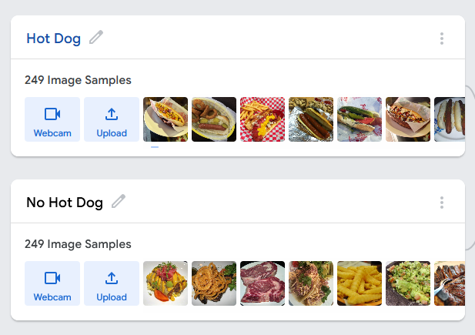
Teachable Machine applies transfer learning, fine-tuning a pre-trained convolutional neural network (CNN) for the custom classification task.

1.2 Dataset
For training the model, the provided dataset hotdog_dataset.zip was used.
Classes:
- Hot Dog – images of hot dogs in different settings and angles
- Not Hot Dog – images of other foods

1.3 Model Training
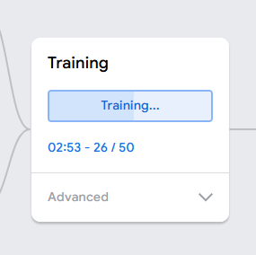
After uploading the images, the model was trained using the default parameters provided by Teachable Machine.
The training process took only a few seconds due to the use of a pre-trained network. Once training was completed, the model was evaluated directly within the web interface.

2. Results

2.1 Evaluation with Training Images
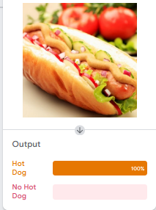
Images of hot dogs from the training set were classified correctly with high confidence (often above 90%).

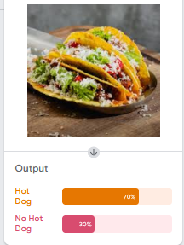
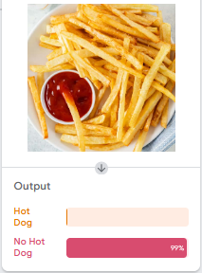
Images from the “No Hot Dog” class were also mostly classified correctly.

3. Discussion and Insights

3.1 Model Limitations
- The model relies on visual patterns, not semantic understanding.
- Foods with a similar shape or color to hot dogs were sometimes misclassified.
- Background elements and presentation (plate, hand, angle) significantly influenced predictions.

3.2 Surprising Observations
- The model occasionally showed uncertainty even for clearly unrelated objects.
- Images with plain or neutral backgrounds produced more reliable predictions.
- The diversity of training images had a stronger impact on performance than the sheer number of images.

